Experiment 1 - Preregistered

# Demographics

We recruited 33, participants from the United Kingdom via Prolific. Due to a coding mistake, four participants did not generate any data. This left us with a mean age of 33.79 (SD = 8.16; females) from the United Kingdom via Prolific. Note that two participants were excluded from the data analysis, but cannot be removed from the demographics due to non-connections between data points and demographics variables.

# Data

## Exclusion

In total, 2 participant where excluded due to low accuracy (> 70%).

Furthermore, 151 trials were lost due to deviating (2.5 SD) response times and none response(s). Representing a loss of 2.07 percent of the data.

Lastly, 1597 trials were removed due to a wrong response on the inducer trial. Representing a loss of 21.86 percent of the data.

A total of 1748 (ignoring excluded participants, we are left with: 1748) trials were lost. Representing a loss of 23.93percent of the data.

## Summary

### Table

Table XX *Test statistics for the experimental conditions*

|  | Incongruent | |  | Congruent | |  |  | Bayes | | |  |  |
| --- | --- | --- | --- | --- | --- | --- | --- | --- | --- | --- | --- | --- |
|  | *M* | *SD* |  | *M* | *SD* | *M*~diff~ |  | *M*~est~ | BF~10~ | HDI |  | *d* |
| RT | 666.00 | 111.00 |  | 647.00 | 103.00 | 18.5* |  | 16.80 | 3.08 | [2.2, 31.1] |  | 0.17 |
| PCT | 0.92 | 0.07 |  | 0.96 | 0.03 | -0.04* |  | -0.04 | 9.48 | [-0.06, -0.01] |  | 0.74 |

*Note.* The tests have 26 degrees of freedom. * *p* < .05 ** *p* < .01 *M* = Mean, *SD* = standard deviation, *M*diff = Differences of the means, HDI = highest density interval, *d* = Effect size.

**remove extra zeros**

### Figures

#### Linerange

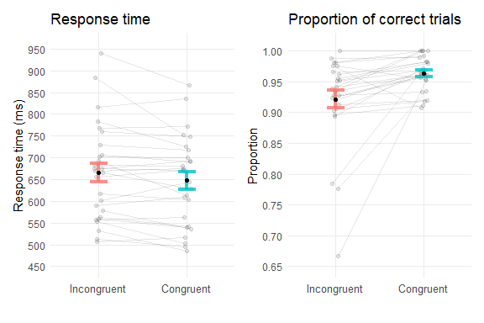

#### Bar plot

